**1st Table – employee_info**

CREATE TABLE employee_info(

emp_id INT primary key,

emp_name VARCHAR(50),

emp_lname VARCHAR(50),

Department VARCHAR(50),

Project VARCHAR(50),

Address VARCHAR(100),

DOB DATE,

Gender CHAR(1)

);

INSERT INTO employee_info VALUES

(1,'Sanjay','Mehra','HR','P1','Hyderabad','1976-12-01','M'),

(2,'Ananya','Mishra','Admin','P2','Delhi','1968-05-02','F'),

(3,'Rohan','Diwan','Account','P3','Mumbai','1980-01-01','M'),

(4,'Sonia','Kulkarni','HR','P1','Hyderabad','1992-05-02','F'),

(5,'Ankit','Kapoor','Admin','P2','Delhi','1994-07-03','M');

Desc employee_info;

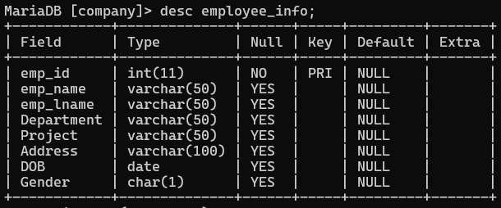

Select * from employee_info;

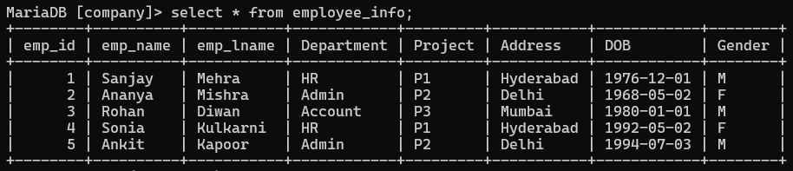

**2nd Table – employee_position**

CREATE TABLE employee_position (

emp_id INT primary key,

emp_position VARCHAR(50),

date_of_joining DATE,

salary INT

);

INSERT INTO employee_position VALUES

(1, 'Manager', '2024-05-01', 500000),

(2, 'Executive', '2024-05-02', 75000),

(3, 'Manager', '2024-05-01', 90000),

(2, 'Lead', '2024-05-02', 85000),

(1, 'Executive', '2024-05-01', 300000);

Desc employee_position;

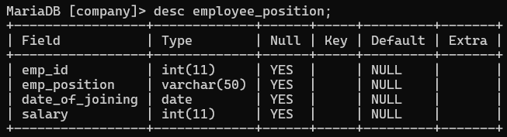

Select * from employee_position;

